

**NRCS Geospatial Nutrient Tool (GNT)**

**User Guide**

**Tool Version – 1.0.1**

**November 2024**

Table of Contents

Overview 2

Purpose 2

State Tool Administrator 2

User Requirements 2

System Requirements 2

Install Folder Reference 2

Project Folder Reference 2

Lesson Outline 3

Lesson 1 – Create GeoPortal Account 4

Lesson 2 – Install Base Software 5

Install ArcGIS Pro 5

License ArcGIS Pro 5

Configure ArcGIS Pro Settings 5

Configure Portals in ArcGIS Pro 6

Lesson 3 – Install GNT Pro 7

Delete Existing Install 7

Download GNT Pro 7

Unzip GNT Pro 7

Lesson 4 – Open the GNT Template 8

Open the Template 8

Set Map Projection 8

(Optional) Add Additional Data to the Project 9

(Optional) Save a Custom Template 9

Lesson 5 - Create GNT Project (Tool 01.) 10

Obtain Case PLU Data 10

Add Case PLU Data to the Project 10

Create a New GNT Project 10

Adjust Layers 12

Save as a New Project 12

Lesson 6 – Download Soil Data (Tool 02.) 13

Adjust Soil Layer 13

Save the Project 13

Lesson 7 – Digitize Setback Features (Edit Session) 14

Prepare Layers for Editing 14

Setup Editing 15

Digitize New Setback Features 15

Editing Objectives, Tips, and Tricks 16

Completing Edits 17

Lesson 8 – Create Setback Buffers (Tool 03.) 18

Save the Project 18

Lesson 9 – Create MMP File (Tool 04.) 19

Lesson 10 – Customize Map Layout 20

Open the GNT Layout 20

Update the Title 20

Customize the Legend 20

Adjust Zoom and Scale 21

Adjust Scale Bar 22

Adjust Other Layout Elements 22

Lesson 11 – Export Map Layout 23

Export a JPEG 23

Export a JPEG 23

Finish Up 23

Appendix A – Overview of the ArcGIS Pro Interface 24

Definitions 24

Catalog Pane 25

Map (Map Frame) 27

Contents Pane 27

Map Tab 28

View Tab 28

Edit Tab 29

Project Tab 29

Quick Access Toolbar 29

Layout 30

Running a Toolbox Tool 32

Appendix B – Basic Editing in ArcGIS Pro 34

Edit Tab 34

Select Features 34

Start/Stop/Save/Discard Edits 34

Undo/Redo 35

Appendix C – Working with Annotation 36

Appendix D – Recovering the Installed Layout 39

Appendix E – Troubleshooting 40

Common Tool Errors (red status) 40

Troubleshooting Edit Locks 41

Issue Reporting 42

# Overview

## Purpose

The Natural Resources Conservation Service (NRCS) conducts nutrient management planning and uses multiple systems to assist planners in creating such plans. The Geospatial Nutrient Tool (GNT) is one such tool that is used to develop setback acreage maps and computations for transfer to the Manure Management Planning tool.

## State Tool Administrator

GNT Pro Tool is designed to be customized and distributed at the State level by one or more staff members designated by the State Conservationist (e.g., Business Tools Specialist, GIS Specialist, and/or Area staff or Subject Matter Expert positions). This guide refers to the designated staff member(s) as the State Tool Administrator. The State Tool Administrator is responsible for customizing and deploying the HELC Tool to their state, and training and supporting the HELC Tool within their state.

## User Requirements

GIS Skills – GNT Pro requires use of ArcGIS Pro. Users require basic skills in the ArcGIS Pro user interface, map navigation, toolbox use, and point, line, and polygon editing, as well as understanding how to manually update the zoom level and extent of content within map frames on a layout. Support from the State GIS Specialist and/or State Tool Administrator is required to ensure that users properly install and use GNT Pro.

## System Requirements

GNT Pro requires the following software and accounts.

1. ArcGIS Pro version 3.1.x or higher (3.3.x recommended) with an *Advanced* license.
2. Manure Management Planner (MMP) 4.0.3 or newer.
3. The GNT-ArcGIS Pro tool folder.

While the GNT itself does not have any specialized licenses or installation packages, it is dependent on ArcGIS Pro with an *Advanced* license and Manure Management Planner (MMP). USDA does not provide ArcGIS Pro installation files or licenses, or MMP installation files to Technical Service Providers (TSPs). TSPs are responsible for their own acquisition and use of ArcGIS Pro and MMP to use the GNT. This guide calls out reminders to this information, where applicable.

## Install Folder Reference

These lessons may refer to *<install folder>* directory path. This refers to the complete folder path above the *GNT-ArcGISPro* folder. The developers recommend using **C:\GIS_Tools** as the install folder to contain the *GNT-ArcGISPro* folder. Other locations should work, but the above path will be used as the reference in this guide.

## Project Folder Reference

The lessons may refer to a project folder. This refers to the folder path that gets created when a new project is started. New project folders are created within the **C:\GNT** folder (this folder will be created the first time the tool is run). The folder name will have the state abbreviation, county FIPS code, farm number, year, and month for the project and when it was started.

## Lesson Outline

The basic workflow for GNT is to add the required software to your computer and then use the ArcGIS Pro default template provided with the tool, or a custom template provided by the NRCS State Office[1], to open a project and go through the workflow for a new request.

**Part 1 – Installation and Configuration (One-time Process)**

These lessons focus on installing and configuring the tool.

* Lesson 1 – Create GeoPortal Account
* Lesson 2 – Install Base Software (ArcGIS Pro)
* Lesson 3 – Install GNT Pro
* Lesson 4 – Open the GNT Template

**Part 2 – Project Execution**

These lessons focus on running a project through the GNT process to prepare data for MMP.

* Lesson 5 – Create GNT Project (Tool 01.)
* Lesson 6 – Download Soil Data (Tool 02.)
* Lesson 7 – Digitize Setback Features (Edit Session)
* Lesson 8 – Create Setback Buffers (Tool 03.)
* Lesson 9 – Create MMP File (Tool 04.)

**Part 3 – Map Creation**

These lessons focus the steps to prepare maps for use with a plan.

* Lesson 10 – Customize Map Layout
* Lesson 11 – Export Map Layout

# Lesson 1 – Create GeoPortal Account

**Note:** Only complete this lesson if you do not already have a GeoPortal account AND if you are an NRCS employee, partner, or contractor with direct access to USDA systems. This lesson is not applicable to Technical Service Providers (TSPs), as they do not have access to the USDA network and the link in this lesson will not work outside of USDA. Supplemental base data and imagery are the responsibility of the TSP to add to projects, if they use the GNT.

USDA users need accounts on the NRCS GeoPortal to have access to additional imagery basemaps within GNT. This section provides instructions for users to create portal accounts if they don’t already have them.

* Open Chrome or Edge, or a new tab in one of those browsers.
* Navigate to <https://gis.sc.egov.usda.gov/portal/home>
* Click *Sign In* in the top-right corner of the screen to sign-in with your LincPass or Eauth.
* After signing-in, the GeoPortal account is setup, and you can sign-out or close the browser tab.

# Lesson 2 – Install Base Software

All base software is available to NRCS employees, contractors, and partners through Software Center. If there is any trouble with Software Center installs, you will need to contact IT for assistance. USDA does not provide installation files or licenses for ArcGIS Pro to TSPs.

## Install ArcGIS Pro

ArcGIS Pro is required for the GNT Pro tool. ArcGIS Pro is available through Software Center. If there is any trouble with Software Center installs, you will need to contact CEC for assistance.

ArcGIS Pro is a large program and is recommended to perform the install while connected to the USDA network via the best available network connection, typically the Service Center or duty station for an employee. It is recommended that users within the same work unit (e.g., office, team, area, and/or state) use the same version to help minimize warnings when opening APRX project files in this, and other ArcGIS Pro tools. All older versions of ArcGIS Pro 3 are forward compatible with newer versions.

The following versions of ArcGIS Pro are supported by GNT Pro and are available in Software Center:

* **ArcGIS Pro 3.3.x (recommended)** – Install ArcGIS Pro 3.3.1 (v3.3.1.52636) followed by the latest ArcGIS Pro Patch for version 3.3 (e.g.; ArcGIS Pro Patch 3.3.2).

OR

* **ArcGIS Pro 3.2.x** – Install ArcGIS Pro 3.2.0 (v3.2.0.49743) followed by the latest ArcGIS Pro Patch for version 3.2 (e.g., ArcGIS Pro Patch 3.2.3)

OR

* **ArcGIS Pro 3.1.x** – Install ArcGIS Pro 3.1.0 (v3.1.41824) followed by the latest ArcGIS Pro Patch for version 3.1 (e.g., ArcGIS Pro Patch 3.1.6)
* **Notes**:
  + GNT has not been tested with new versions of ArcGIS Pro above version 3.3. Use new versions of ArcGIS Pro with GNT at your own risk.
  + GNT is *not* compatible with ArcGIS Pro versions 3.0.x and below.

## License ArcGIS Pro

ArcGIS Pro 3.1.x and later have licensing automatically configured when the installation is performed from Software Center. While no additional extensions are needed for GNT Pro, you should also review and enable any additional Extensions that you may need for other GIS workflows. USDA employees can refer to the *Licensing* section of the [***Getting Started with ArcGIS Pro***](https://usdagcc.sharepoint.com/sites/FPAC-NRCS-GIS/Training/Forms/AllItems.aspx?id=%2Fsites%2FFPAC%2DNRCS%2DGIS%2FTraining%2F1%20Getting%20Started%20with%20ArcGIS%20Pro%2Epdf&parent=%2Fsites%2FFPAC%2DNRCS%2DGIS%2FTraining) guide from FPAC GEO for details on configuring Extensions.

## Configure ArcGIS Pro Settings

For best results, the Project Recovery setting in ArcGIS Pro should be disabled. This prevents inadvertent file locks being applied to temporary datasets used for processing in the tools if a script fails or if ArcGIS Pro crashes. These steps are needed after any ArcGIS Pro install or patch.

* Open any ArcGIS Pro project (blank or existing).
* Click *Project* or *Settings*, then click *Options*, and then click *General*.
* Expand *Project Recovery* and disable the *Create a backup…* option.
* Close the project.

## Configure Portals in ArcGIS Pro

**Note:** Only complete this section if you are an NRCS employee, partner, or contractor with direct access to USDA systems. This lesson is not applicable to Technical Service Providers (TSPs), as they do not have access to the USDA network and the link in this section will not work outside of USDA.

GNT connects to the NRCS GeoPortal to access imagery basemaps. Use these steps to configure the connection to GeoPortal after creating your account (see above) and installing ArcGIS Pro (see above).

* Launch ArcGIS Pro (***Start à ArcGIS à ArcGIS Pro***). In the lower-left corner of the Pro window, click ***Settings***. From the list of settings, click ***Portals***.  
  Note: If you are in an active project, click the ***Project*** tab to access the ***Portals*** menu.
* A list of portals will be displayed. It will contain ArcGIS Online ([www.arcgis.com](http://www.arcgis.com)) by default, and any portals you’ve previously added. For first time users, only ArcGIS Online will be visible.

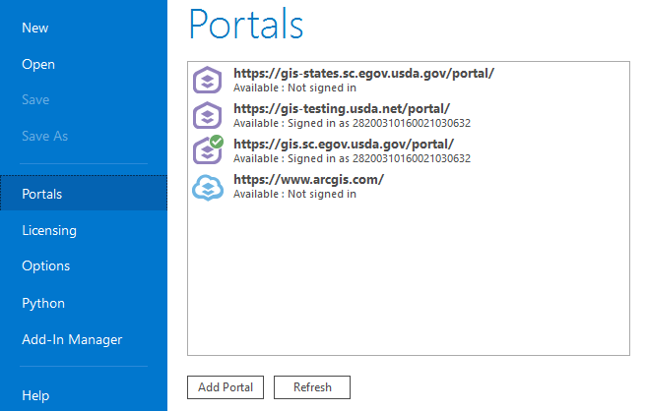

* 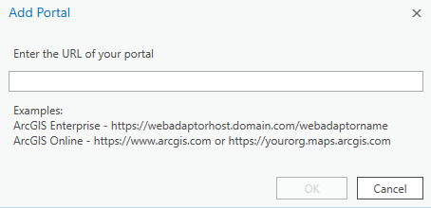If the below GeoPortal URL is not in your displayed list, click ***Add Portal***, type the URL for the portal to add, and then click ***OK***.

https://gis.sc.egov.usda.gov/portal

# Lesson 3 – Install GNT Pro

## Delete Existing Install

Old versions of GNT Pro should be deleted prior to downloading or installing a new version. This section is only needed if you have pre-existing versions of GNT Pro, and previously run projects.

* Open *File Explorer* and navigate to *C:\GIS_Tools*, or to the other location your state has designated for tool installation.
  + At the installation location level (e.g., *C:\GIS_Tools*, or another folder you’ve designated for install) select and delete the *GNT-ArcGISPro* folder.
* Navigate to *C:\GNT*, if it exists.
  + **Real Sites Run for Production**: Backup project folders to an external drive. Then delete the project folders from *C:\GNT*. Any in-progress projects may need to be started over in the new version.
  + **Test Sites Run for Training**: Delete these project folders from *C:\GNT*.

## Download GNT Pro

The GNT can be downloaded from GitHub at: <https://github.com/USDA-NRCS/GNT-Pro>.

When you visit the page, click the green ***Code*** button and then click ***Download Zip***.

**Note:** NRCS employees may receive a custom version of the tool from their state office instead. If so, it is likely to also be provided by zip file and that version can be used instead of the version from GitHub.

## Unzip GNT Pro

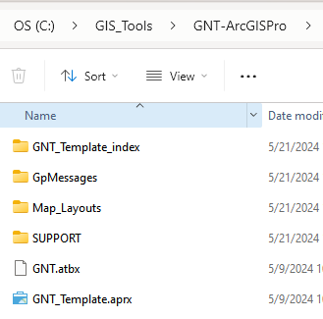GNT Pro must be unzipped so that it resides in in a folder on the C: drive on the local computer. A suggested directory that you could create for this purpose would be “GIS_Tools” on the C: drive. If this directory does not exist, you should create it manually in File Explorer prior to unzipping.

After unzipping, the resulting installation path should be:  
**C:\<install folder>\GNT-ArcGISPro**   
It should appear similar to the screenshot to the right.

In this example, the “GIS_Tools” folder is used as the install folder and will remain as the example install folder throughout this guide.

Note: Slight variations of folders and files may exist, compared to the screenshot on this page.

# Lesson 4 – Open the GNT Template

A blank ArcGIS Pro project (APRX) is contained within the install folder and is used to start new projects. **Note:** NRCS employees may receive an additional APRX if their state provides a custom version of the tool along with a custom template. If available, use a state-provided template to get started, otherwise use the default one included in the installation files.

## Open the Template

The GNT runs within ArcGIS Pro. The tool is opened by opening an ArcGIS Pro template project.

* Open File Explorer.
* Navigate to the install folder for GNT.

Note: In our example in this guide, the location would be *C:\GIS_Tools\GNT-ArcGISPro*.

* Double-click the *GNT_Template.aprx* file to open it.

Note: If using a state-provided template or other custom template, open that instead.

* In ArcGIS Pro, open the *GNT Map* within the project, if not already open.
  + **Hint:** The *GNT Map* can be found in the *Maps* section of the *Project* tab of the *Catalog Pane* of ArcGIS Pro. The *Catalog Pane*, if not open, can be found under the *View* tab of the top ribbon menus.

## Set Map Projection

The GNT expects the map coordinate system to use a UTM projection from the WGS 1984 datum. This section describes how to set the coordinate system to one appropriate to your work coverage area.

**Note:** If using a template provided by a state office, or a custom template, this may already be set.

* In the *Contents* pane for the *GNT Map*, right-click the *GNT Map* header name.
* From the pop-up menu, click *Properties*.
* In the *Map Properties* window, click *Coordinate Systems*.
* Complete the next steps in the *XY Coordinate Systems Available* part of the window.
* Click to expand *Projected Coordinate System,* then *UTM,* then *WGS 1984,* and finally *Northern Hemisphere*.
* 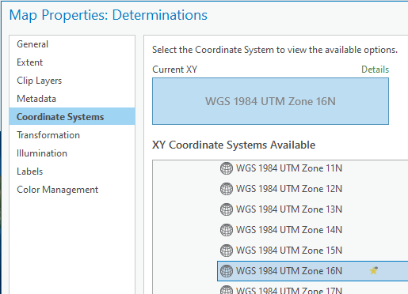A list of UTM Zones for the northern hemisphere is displayed.
* Click to select/highlight the UTM Zone number appropriate to your state or region.  
  **Note:** NRCS employees may refer to this map [link](https://gis.sc.egov.usda.gov/portal/home/webmap/viewer.html?webmap=e5950ed38ac24f71bae6f06f1dc00284) for assistance in selecting a zone.
* Click *OK* to apply the selected coordinate system to the *GNT Map*.
* Click *Project 🡪 Save* to save the project.

## (Optional) Add Additional Data to the Project

Users can add local data to the project that may be needed to supplement the workflow. Examples could include layers containing additional imagery, hydrography, or roads.

Note: NRCS employees may receive a customized version of the tool with one or more custom templates for use within a state from their state office. If so, such templates often have additional data already present, however, users may still add more data if needed.

* Click the *Map* tab in ArcGIS Pro.
* Click the *Add Data* button on the menu ribbon under the *Map* tab.
* Use the file browser to navigate to, select, and add data from your system or network.
  + Note: The scope of adding folder connections or advising on geodata use within any given work unit is outside the scope of this guide. Consult your GIS support staff for assistance when adding data, as needed.
* Repeat the *Add Data* steps above, as needed, to add more layers.
* Click *Project 🡪 Save* to save the project.

## (Optional) Save a Custom Template

After setting coordinate system and adding optional data, you may want to save these changes to a custom template that you can backup and maintain yourself, so that future GNT releases of the default *GNT_Template.aprx* file do not overwrite your customizations. You could then use your own custom template without having to repeat the *Set Map Projection* and *Add Data* steps every time you start a project. You can use your template until a future GNT release indicates that old templates must be replaced for some reason. If you do this, you can replace the steps earlier in this lesson to open the default or state template with opening the custom template you will create in this section.

* Click the *Project* tab in ArcGIS Pro.
* Click *Save Project As*.
* Use the dialog window that appears to navigate to a location on your system, name, and save your custom template.

Note: We suggest navigating to the GNT install folder (e.g., *C:\GIS_Tools\GNT-ArcGISPro*) and naming the file *My_Template.*

* Click *Save* in the dialog window after setting the location and file name for the template.
* Click the back arrow at the top-left of the ArcGIS Pro menus to return to the project.

After creating your own custom template, we advise you to use File Explorer to copy and paste a backup copy of your custom template to a location that gets continuously backed up (anywhere on OneDrive for NRCS employees would work). You can then manually restore your custom template from your backup location in the future, if needed, such as if you get a new computer or have to reinstall ArcGIS Pro and GNT for some reason.

# Lesson 5 - Create GNT Project (Tool 01.)

## Obtain Case PLU Data

Case PLU data for the customer’s site(s) is required for the GNT. NRCS employees may obtain Case PLU data for a project by following the ***Conservation Desktop (CD) User’s Guide Section 5.1.12 (page 1022)***; or by following instructions provided by the State Business Tools Coordinator and/or State GIS Specialist to export the Case PLU from CD.

**Note:** TSPs need to obtain the Case PLU data from the NRCS Office that administers conservation plans for the client in question. The client will need to approve a data release to the TSP for the Case PLU data to be provided.

Once Case PLU data has been obtained, it can be saved anywhere on the local computer and instructions for that procedure are outside the scope of this guide. Note the location where you keep your Case PLU data to be loaded into the project.

## Add Case PLU Data to the Project

Once Case PLU data has been obtained, it must be added to ArcGIS Pro for use with GNT.

* In ArcGIS Pro, click the *Map* tab.
* Click the *Add Data* button on the menu ribbon under the *Map* tab.
* Use the file browser to navigate to, select, and add the Case PLU data to the project.
* Once the Case PLU layer is added to the project, set the symbology for the Case PLU as preferred. A hollow fill with a brightly colored outline that shows up on imagery is recommended. Procedures to set symbology are considered fundamental ArcGIS Pro skills and are outside the scope of this guide.
* Do *not* save the project yet.

## Create a New GNT Project

GNT processes run from the *GNT* toolbox (*GNT.atbx*) found within the ArcGIS Pro template provided with GNT (or customized by the state office or the user in earlier steps in this guide).

* In ArcGIS Pro, open the *Catalog* *Pane*, if not already open, and click the *Project* tab at the top.
  + 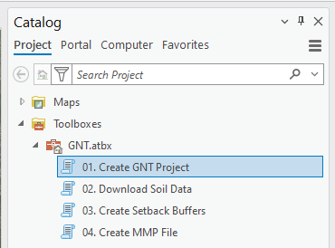Hint: The *Catalog Pane* is found in the *View* tab of the ribbon menus at the top of ArcGIS Pro. When opened, the *Catalog Pane* will be its own window that either floats independently or is docked to one of the sides of the ArcGIS Pro window.
* Expand the *Toolboxes* section.
* Expand the *GNT.atbx* toolbox.
* Double-click the *01. Create GNT Project* tool, and set the following parameters.  
  **Note:** Parameters in the screenshot are example values only. Selections for any given plan may be different that those shown.
  + 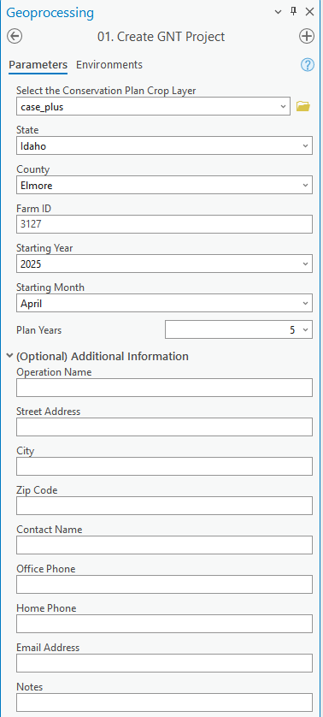In *Select the Conservation Plan Crop Layer*, use the dropdown to select the *Case PLU* layer you previously added to the map.
  + Select the State where the *Case PLU* is located.
  + Select the County where the *Case PLU* is located.
  + Enter a *Farm ID* to use with this site. The Farm or Tract number for the client are recommended.
  + Enter a *Starting Year* for the plan.
  + Enter a *Starting Month* for the plan.
  + Use the *Plan Years* dropdown to select the number of years for the duration of the plan.
  + Expand the *Optional Additional Information* section to complete address information for the client, if needed.
* Click *Run* to start the tool.
* Wait for the tool to finish running.
* Review the messages when the tool finishes running to look for any errors. If the message box for the tool completion is green, there were likely no errors encountered. If there are error messages, review them for possible instructions on how to correct the errors. This will require re-running the tool after addressing the issue that caused the error.

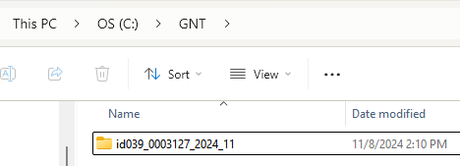A project folder will be created within the *C:\GNT* folder. All products and data for the site will be created in the project folder.

**Note:** If the *C:\GNT* folder did not already exist, it will be created when this tool is run.

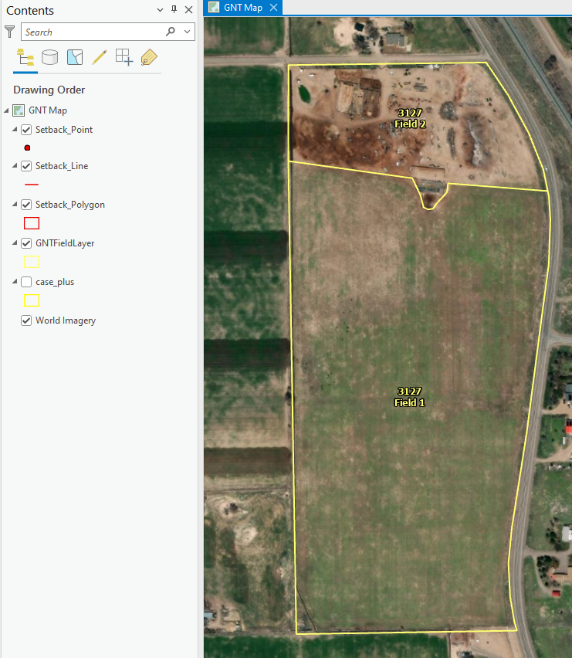Four layers will be added to the map – *Setback Point*, *Setback Line*, *Setback Polygon*, and *GNTFieldLayer*.

## Adjust Layers

Turn layers on and off, as needed, to continue working with the case.

* In the *Contents* pane:
  + Turn off the *Case PLU* layer if present and visible.
  + Turn on the *GNTFieldLayer*, if not already visible.

## Save as a New Project

Save the project in the new project folder that was created.

* Click the *Project* tab in ArcGIS Pro.
* Click *Save Project As*.
* Use the browse window that appears to navigate to the newly created project folder.

**Note:** You may need to click refresh within the browse window for the new project folder to show up.

* Enter a name for the project.
* Click *Save* in the browse window after setting the location and file name for the project.
* Click the back arrow at the top-left of the ArcGIS Pro menus to return to the project.

# Lesson 6 – Download Soil Data (Tool 02.)

This lesson will use one of the layers created in the *Create GNT Project* tool to set an area of interest for downloading soil data needed for the project.

**Note:** This tool requires an internet connection. It uses the USDA public site for *Soil Data Access* to download the data.

* 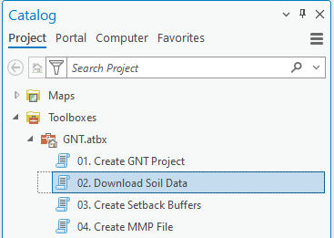In ArcGIS Pro, open the *Catalog* *Pane*, if not already open, and click the *Project* tab at the top.
* Expand the *Toolboxes* section.
* Expand the *GNT.atbx* toolbox.
* Double-click the *02. Download Soil Data* tool.
* Complete the following parameters in the tool:
  + Use the dropdown for *Select the GNTFieldLayer* to select “GNTFieldLayer” which was created in the previous tool.
* 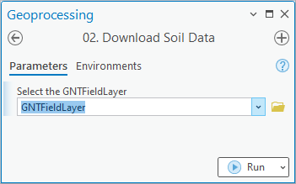Click *Run* to start the tool.
* Wait for the tool to finish running.
* Review the messages when the tool finishes running to look for any errors. If the message box for the tool completion is green, there were likely no errors encountered. If there are error messages, review them for possible instructions on how to correct the errors. This will require re-running the tool after addressing the issue that caused the error.
* A *SoilMap by Landunit* layer is added to the map.

## Adjust Soil Layer

Turn layers on and off, arrange layer ordering, or modify symbology, as needed, to continue working with the case.

* In the *Contents* pane, drag and drop the *SoilMap by Landunit* layer to be below the *GNTFieldLayer*
* Customize the symbology and labels of the *SoilMap by Landunit* layer, as preferred.
  + These customizations are fundamental ArcGIS Pro skills outside the scope of this guide.

## Save the Project

* Click the *Save Project* button in the top-left corner of ArcGIS Pro.

# Lesson 7 – Digitize Setback Features (Edit Session)

This lesson describes digitizing setback features using the ArcGIS Pro editing tools. The features you create need to adhere to the distances established in your state’s Confined Animal Feeding Operation (CAFO) standards. Examples used in this lesson may not be appropriate for your State. Please refer to available resources in your state or contact your State Agronomist, Natural Resource Specialist, or State Resource Conservationist to get the necessary setback distance information.

## Prepare Layers for Editing

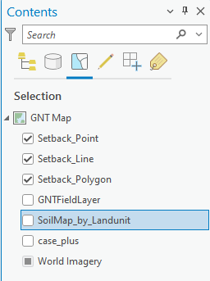Adjust layer settings to minimize incorrect feature interactions while editing.

* At the top of the *Contents* pane, switch from the *List By Drawing Order* tab to the *List By Selection* tab.
* Deactivate the ability to select features from layers that you do not need to interact with while editing. This is likely all layers *other than* the three *Setback* layers.
* 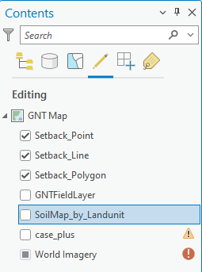At the top of the *Contents* pane, switch from the *List By Selection* tab to the *List By Editing* tab.
* Deactivate the ability to edit features from layers that you do not need to interact with while editing. This is likely all layers *other than* the three *Setback* layers.
* 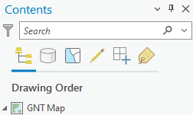At the top of the *Contents* pane, switch from the *List By Editing* tab back to the *List By Drawing Order* tab.

## Setup Editing

Change to the Edit menu to access editing tools.

* At the top of ArcGIS Pro, click the *Edit* tab

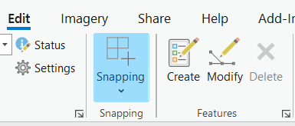

* On the *Edit* tab, click the *Create* button, found in the features panel of the ribbon.
* The *Create Features* window will open. It will either be a free-floating window that can be moved anywhere, or it can be docked to the edge of the ArcGIS Pro window.
* 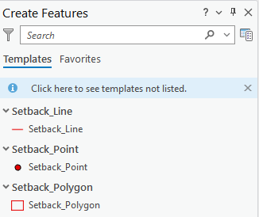The *Create Features* window is organized by each layer that can be edited. For a layer to appear in this window, it must be visible in the *List By Drawing Order* tab of the *Contents* pane and it must also be active in the *List By Editing* tab of the *Contents* pane (see the previous section).
* Any features in ArcGIS Pro that can be edited (see the *List By Editing* tab of the *Contents* pane) can be edited at any time. There are no *Start Editing* or *Stop Editing* commands needed to open and close an “edit session”.

## Digitize New Setback Features

Use the tools in the *Create Features* window to create new setback features of either point, line, or polygon type. The process to create a new feature starts the same for all feature types.

* In the *Create Features* window, click the layer for creating a feature.

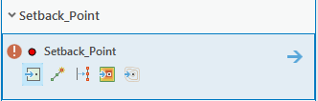

* Click the first tool on the left side of the list of the tools that appear. This is always the default or generic create feature tool for the geometry type of the selected layer.
* 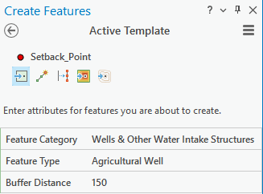Click the arrow icon on the right side of the window to go to the template details page.
* In the *Active Template* window, complete the following entries, which will pre-populate the attributes for new features:
  + Select a *Feature Category*. This updates the *Feature Types* list.
  + Select a *Feature Type*.
  + Enter a *Buffer Distance*, in feet.
  + If present, enter a *Buffer Sides* choice of *Left*, *Right*, or *Both*.
* Move the cursor over the map and a crosshair will be displayed with the current create feature tool active.
* Use a single-click to place a single point, or a single vertex for a line or polygon.
  + If digitizing a point, the feature is created and automatically selected after a single-click.
  + 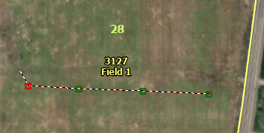If digitizing a line or polygon, make additional single-clicks to shape the line or boundary.
  + If digitizing a line or polygon, press F2 on the keyboard after placing the last point/vertex to finish creating the feature. Double-click can also complete a line or polygon if done at the last vertex location, but if done incorrectly the shape of the resulting feature may be altered in an undesirable way.
  + If digitizing a line, the “left” or “right” side of the line for *Buffer Sides* purposes is considered as if you were standing at the starting point of the line and facing along the line in the direction of digitizing additional points to create the line.
* A screenshot from ArcGIS Pro showing the icons for Save Edits and Discard Edits, two buttons that are available on the Edit menu of ArcGIS Pro.After completing one or more new features, click the *Save Edits* button on the ribbon under the *Edit* tab.
  + **Note:** If recent edits since starting or since the last *Save Edits* are not desired, clicking *Discard Edits* instead will erase all pending edits. Use *Discard Edits* with caution.

## Editing Objectives, Tips, and Tricks

The goal of the editing session is to digitize all features that require setbacks using the distinct *Feature Category*, *Feature Type*, *Buffer Distance*, and *Buffer Sides* if applicable, that the editor defines while editing. The *Buffer Distance*, and *Buffer Sides* if applicable, are used by subsequent GNT scripts to create the actual setback features.

* Continue adding features. Each time a new feature category and type is needed, use the *Create Features* window to select the layer type, and then click the forward arrow into the *Active Template* window to set the category, type, and buffer traits of the feature to be digitized.
* Do not double-click when digitizing *Setback Point* features. This will often add two matching points exactly on top of each other.
* Using *Save Edits* will reset the list of edits under the *Undo* button to be blank. Edits completed prior to the most recent click of *Save Edits* cannot be reversed using *Undo*.
* 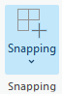*Snapping* is typically active by default in ArcGIS Pro. The settings for *Snapping* can be viewed in the *Snapping* pop-out menu on the *Edit* tab. Clicking the *Snapping* button under the *Edit* tab will deactivate all snap settings.
* Active *Snapping* can be temporarily suspended while in-progress on an active edit by holding the *Spacebar* on the keyboard. As long as *Spacebar* is held, all *Snapping* settings are ignored. This is useful when editing features near existing features, but *Snapping* is interfering with the edit.
* While any editing tool is active, the map can be panned by clicking-and-dragging using the middle mouse button without switching away from the editing tool. The map can also be zoomed by using the scroll wheel on a mouse. On some mouse models, the scroll wheel doubles as a middle mouse button.
* A screenshot from ArcGIS Pro showing the Delete button/icon which is available on the Edit tab.To delete a feature, use the *Select* tool to select it, and then click the *Delete* button on the ribbon under the *Edit* tab.

## Completing Edits

Use the editing instructions, objectives, and tips in the previous sections to complete all edits. When finished, review the following steps to complete all edits.

* 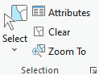Click the *Clear* button on the *Edit* tab in the *Selection* area of the ribbon. This will clear the active selection of any features, digitized or otherwise.
* Click the *Save Edits* button on the ribbon under the *Edit* tab.

# Lesson 8 – Create Setback Buffers (Tool 03.)

This step uses the layers created in the editing session to create a new setback layer in the map.

* 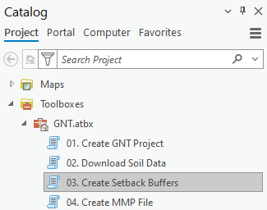In ArcGIS Pro, open the *Catalog* *Pane*, if not already open, and click the *Project* tab at the top.
* In the *Catalog Pane*, under the GNT.atbx,double-click *03. Create Setback Buffers*.
* **Note:** Complete creating setback features in the previous lesson and *Save Edits* before running this script.
* 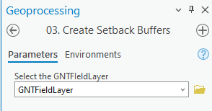In the dropdown, select *GNTFieldLayer*.
* Click *Run* to start the tool.
* Wait for the tool to finish running.
* Review the messages when the tool finishes running to look for any errors. If the message box for the tool completion is green, there were likely no errors encountered. If there are error messages, review them for possible instructions on how to correct the errors. This will require re-running the tool after addressing the issue that caused the error.

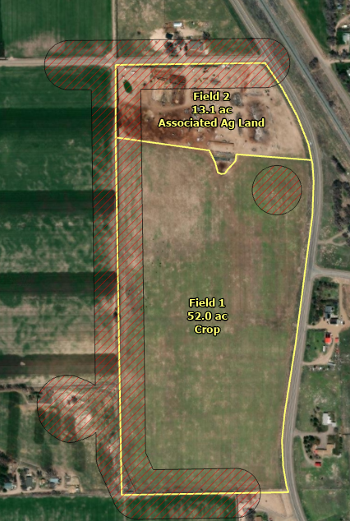A layer named *Setback Buffer* is added to the map. This layer contains all buffers created around the features that were digitized during the previous editing steps, out to the distance specified for each digitized feature. All setbacks are in a single layer, regardless of input feature category or type, with any overlapping setbacks integrated together. The *GNTFieldLayer* is also re-added to the map, with updated labeling. The *SpreadSize* field in the *GNTFieldLayer* attribute table is also calculated for remaining spreadable acres in each field (i.e., excludes the setback acres that fall within the field).

## Save the Project

* Click the *Save Project* button in the top-left corner of ArcGIS Pro.

# Lesson 9 – Create MMP File (Tool 04.)

This tool creates a Manure Management Planer (MMP) project file (.mmp) in the *CNMP_Reports* folder for the project and automatically launch MMP using that file.

**Note:** This tool requires MMP to be installed on the computer.

* 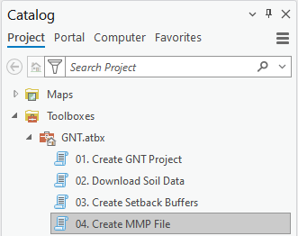In ArcGIS Pro, open the *Catalog* *Pane*, if not already open, and click the *Project* tab at the top.
* In the *Catalog Pane*, under the GNT.atbx,double-click *04. Create MMP File*.
* 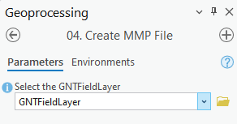In the dropdown, select *GNTFieldLayer*.
* Click *Run* to start the tool.
* Wait for the tool to finish running.
* Review the messages when the tool finishes running to look for any errors. If the message box for the tool completion is green, there were likely no errors encountered. If there are error messages, review them for possible instructions on how to correct the errors. This will require re-running the tool after addressing the issue that caused the error.
* MMP will open.
  + The *General* tab will open by default. It will contain the information entered under the optional section of tool *01. Create GNT Project*, if such information was entered when that tool was run.
  + The *Fields* tab will contain the information that is able to be transferred over from ArcGIS Pro from the *GNTFieldLayer* and *SoilMap by Landunit* layers.
  + **Note:** If soil map units are included in the data that are no longer valid, then a warning message will appear when MMP opens. You can click *No* to the prompt and then manually select the dominant soil to go with each field in the plan using the MMP interface, as needed. This step is outside the scope of this guide.
* Additional steps in MMP are outside the scope of this guide. The next lesson in this guide returns to ArcGIS Pro to complete the creation of maps to accompany the plan.

# Lesson 10 – Customize Map Layout

The GNT comes with a generic *GNT Layout* file that can be used to make maps. This lesson describes simple steps to configure the layout to prepare it for export.

## Open the GNT Layout

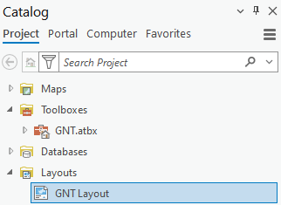If the *GNT Layout* is not already open, it can be opened from the *Catalog Pane*.

* In ArcGIS Pro, open the *Catalog* *Pane*, if not already open, and click the *Project* tab at the top.
* Expand the *Layouts* section.
* Double-click the *GNT Layout* to open it.
* When the layout it open, it will appear as a tab next to the *GNT Map* tab.
* Expand the *Map Frame* item and the *GNT Map* item within the *Contents* pane of the layout, if not already expanded.
* Right-click the *GNTFieldLayer* and click *Zoom to Layer*. This will zoom the map to the region of your site(s). Further refinements to the map extent will be made in later steps in this lesson.

## Update the Title

Set a map title. Repeat as necessary for any subsequent maps.

* Double-click the *Map Title* directly on the layout page.
* Type a new map title.
* Click outside of the highlighted/open *Map Title* box to apply the change. Do not press *Enter* or *Return* on the keyboard.

## Customize the Legend

Minor adjustments can be made to the legend to improve and refine it.

* 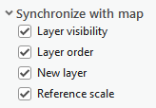Right-click the *Legend* box on the map and then click *Properties*.
* In the *Element–Legend* pane that opens, click on the *Layer order* option in the *Synchronize with map* section.
* 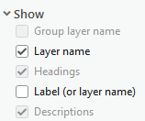In the *Element–Legend* pane, click the *Show properties…* button under *Legend Items*.
* Under *Show* click on *Layer name* and click off *Label (or layer name)*.
* 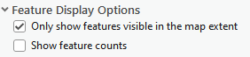Under the *Feature Display Options* section, click on *Only show features visible in the map extent*.
* Click the *Back* arrow.
* 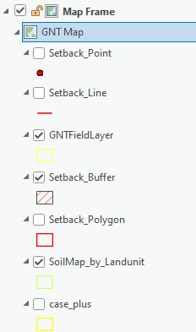In the *Contents* pane for the layout, expand the *GNT Map* item.
  + Use this area to turn layers on or off that should or should not be displayed in the legend.
  + Use this area to drag-and-drop layer names to re-order the order in which they appear in the legend.
* Close the *Element – Legend* pane.

## Adjust Zoom and Scale

The map extent within the layout must be updated for each map to be made. These instructions provide the steps to do that. Please note that the Map and the Layout are separate items. Changing the zoom and extent in the *GNT Map* will not automatically change it in the *GNT Layout*. Instead, users must *Activate* the *Map Frame* for the *GNT Map* on the *GNT Layout* and then pan and zoom work normally.

* Double-click the *Map Frame* on the *GNT Layout* page or in the *Contents* pane of the layout.
* Click *Activate*. The area of the layout page other than the map frame will grey-out and the *Explore* tool will become active.
* Use normal map pan and zoom functions within the *Map Frame* area while the *Explore* tool is active to zoom in on a portion of the plan (e.g. a particular tract).
  + **Tip:** For precise control of scale, type a desired scale value in the scale box in the bottom-left corner of the layout page and then press *Enter* or *Return* on your keyboard.
* When finished adjusting the scale and extent of the map, click the *Layout* tab at the top of the menu ribbon in ArcGIS Pro, and then click *Close Activation*.
  + Alternately, click the *Back* arrow next to the *Layout* hyperlink header in the top-left of the layout window.
* Repeat these steps as needed between each map export.

## Adjust Scale Bar

The default scale bar is in miles. It can be changed to feet and further refined.

* Right-click the scale bar on the layout page and then click *Properties*.
* On the *Options* tab of the *Scale Bar* element pane go to the *Map Units* section.
  + **Hint:** Tabs for different settings relating to the scale bar appear across the top of the *Scale Bar* element pane. The *Options* tab is the leftmost tab and appears as a small text bubble floating above a generic page of content.
* Change the *Map Units* dropdown to *Feet*. This will also automatically change the *Label Text* value to *Feet*.
* Click the *Properties* tab of the *Scale Bar* element pane.
  + **Hint:** The *Properties* tab is 2nd for them the left and appears as a tiny scale bar graphic.
* Change *Fitting Strategy* to *Adjust Width*.
* Change *Division Value* to a value that works for the current scale of your map.
  + **Hint:** The current scale is shown in the bottom-left corner of the layout screen.
  + **Common scales and their suggested division values:**
    - 1:3,960 330
    - 1:7,920 660
    - 1:15,840 1320
* Change the number of *Divisions* to 3.
* Change the number of *Subdivisions* to 2.
* Check on the box to *Show one division before zero*.
* Under *Marks* change *Frequency* to *Divisions and first midpoint*.
* Click and drag the scale bar and/or the north arrow on the layout page so they do not overlap each other or the Legend.
  + **Note:** The Legend position can be moved the same way, if needed.
  + **Hint:** Hold space bar while dragging layout elements on the page to prevent them from snapping to any guidelines that are linked to the layout page ruler(s).
* Repeat these steps as needed between each map export.

## Adjust Other Layout Elements

Adjust any other elements on the layout page, as needed. Consult your GIS Support staff and/or State Office for guidance or assistance.

# Lesson 11 – Export Map Layout

After customizing the map layout, it should be exported as a JPEG (.jpg) or bitmap (.bmp) file to subsequently be inserted into a Conservation Nutrient Management Plan document, as needed.

**Warning:** Bitmap files are much larger than JPEG files.

* Click the *Share* tab from the ArcGIS Pro menu ribbon.
* Click *Export Layout* in the *Output* section of the *Share* ribbon. This opens the *Export Layout* pane.

## A screenshot of the Export map file interface in ArcGIS Pro with entries completed for exporting a JPEG, as described in the text of this section of the guide.Export a JPEG

* Set *File Type* to JPEG.
* Click the browse button to navigate to an output folder and name the file.
  + Click OK when finished setting the output location and name.
* Move the *Quality* slider for *Compression* to 75.
  + Hint: The number only displays as you adjust the slider.
* Set the *Resolution* to 150 DPI.
* Confirm the *Color depth* is *24-bit True Color*.
* Click *Export*.

## Export a JPEG

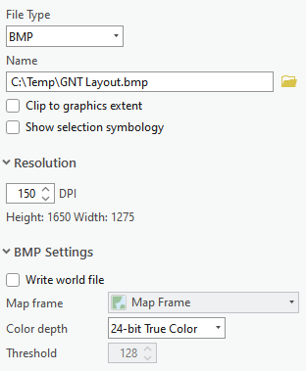

* Set *File Type* to BMP.
* Click the browse button to navigate to an output folder and name the file.
  + Click OK when finished setting the output location and name.
* Set the *Resolution* to 150 DPI.
* Confirm the *Color depth* is *24-bit True Color*.
* Click *Export*.

## Finish Up

* Return to the *Lesson 10 – Customize Map Layout* to adjust the layout for the next map for the site, if working with multiple maps.
* Repeat the steps in this lesson to export the next map.

# Appendix A – Overview of the ArcGIS Pro Interface

This section describes the basics of the ArcGIS Pro interface. Some panels may float or be docked differently than where shown in the following screenshots.

## Definitions

The following terms are defined for use in the HELC Tool workflow.

* **Map** – A *Map* is an object in ArcGIS Pro in which you display GIS layers or data. The *Map* is synonymous with the *Data Frame* view in ArcMap. The GNT templates come with a *Map* named *GNT Map*. This is the map that must be used for GNT work.
* **Map Frame** - The *Map Frame* is the object within a *Layout* that shows the contents and extent of a *Map* on the *Layout*. It is synonymous with the *Layout* view from ArcMap.
* **Layout** – A *Layout* is an object in ArcGIS Pro that consists of a preview page on which a *Map* and other elements are formatted for the creation of map products, such as an output PDF.
* **Contents Pane** – While a *Map* in ArcGIS Pro is open, the *Contents* pane is where the layers will be listed and can have their visibility and other properties controlled. This is synonymous with the Table of Contents in ArcMap.
* **Ribbon** – The interface at the top consisting of different tabs (menus), each of which contains different ArcGIS Pro functions. The ribbon is context sensitive, and different tools or ribbon tabs become active when items are selected on other panels such as a map, layout, or layer name.
* **Geoprocessing** – A window in ArcGIS Pro where the GNT scripts will open and be run.
* **Catalog Pane** – A pane in an ArcGIS Pro project to view the project’s contents, including all its *Maps, Layouts,* and *Toolboxes*. The *Catalog Pane* is described in more detail later in this section.
* **Portal Status** – This is a menu in the top-right of ArcGIS Pro where you can switch your active Portal and manage your sign-in status for one or more Portals, if you have multiple Portals.

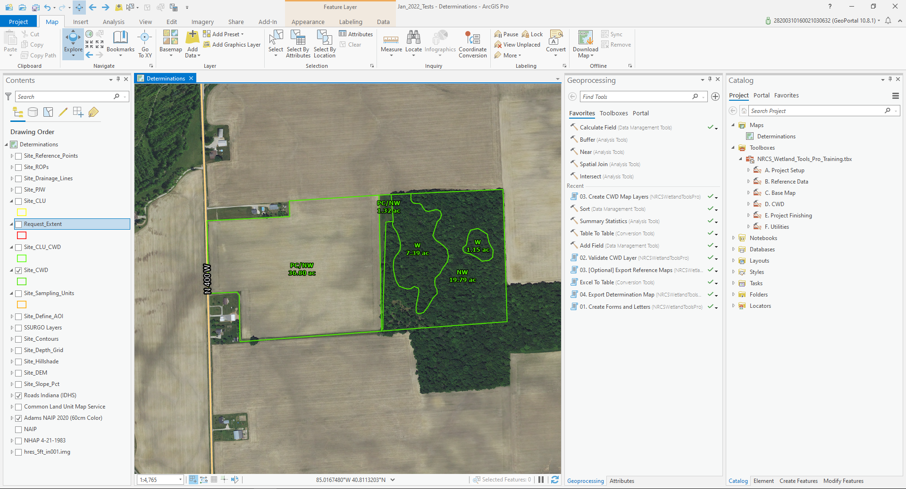

**PORTAL STATUS**

**GEOPROCESSING**

**RIBBON**

**MAP**

**CATALOG  
PANE**

**CONTENTS**

## Catalog Pane

All aspects of GNT Pro can be managed through the *Catalog Pane*. This pane displays all the components of the current project (APRX) file. If a *Map*, *Layout*, or *Toolbox* is closed and you can’t find it, go to the *Catalog Pane* and expand the heading for the content type you are seeking, and then double-click an item to expand or open it.

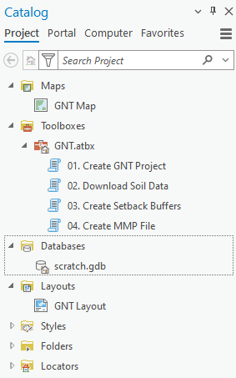To access the *Catalog Pane* (if it is not visible):

* Click the *View* tab on the *Ribbon* in ArcGIS Pro.
* Click *Catalog Pane*.
* The *Catalog Pane* should open or appear if it’s not already open.
* The *Catalog Pane* may be floating on another monitor (if you have multiple) or it may already be docked.

Using the *Catalog Pane*:

* If the contents of the project are not visible in the *Catalog Pane*, click the ***Project*** tab at the top-left of the pane so it is underlined (see the top of the accompanying screenshot).
* Expand the carats/arrows in front of an item in the Catalog to explore the contents of the project.
* Double-click an item in the pane to open it (e.g. a *Map*, a *Toolbox*, a *Layout*, etc…).

### Explore the Catalog Pane

The following parts of the Catalog Pane are commonly used in the HELC Tool workflows:

* ***Maps*** – Stores the *GNT* map for the GNT templates. If you close the *GNT* map for any reason, you can expand the *Maps* heading/icon of the *Catalog Pane* and then double-click the *GNT Map* item to re-open it.
* ***Toolboxes*** – Stores the ArcToolbox for GNT Pro, called *GNT.atbx*. To access the tools, expand the *Toolboxes* section of the *Catalog* pane and then expand the *GNT* toolbox. Double-click a tool to open it.
* ***Layouts*** – Some tools in the GNT workflow will require you to open the *GNT Layout* item. This layout can be accessed from the *Layouts* section of the *Catalog Pane*.
* ***Folders*** – This lists the folder connections stored in the project. You can map additional folder connections as needed. To do so:
  + Right-click the ***Folders*** heading/icon in the *Catalog Pane*.
  + Click ***Add Folder Connection***.
  + Use the browse window to navigate to and select a folder.
  + Click ***OK***.

## Map (Map Frame)

A *Map* is an object in ArcGIS Pro in which you display GIS layers or data. The *Map* is synonymous with the *Data Frame* view in ArcMap. When you open a GNT template, the *GNT Map* should be open by default. If not, it can be opened from the *Maps* section of the *Catalog Pane* (see previous section). The map should occupy the central viewing area of the ArcGIS Pro interface.

The main tools for interacting with the map are the *Explore* tool, the *Select* tool, the *Measure* tool, and various editing tools (see tab descriptions in the sections below).

When a map object is viewed on a *Layout* it is referred to as a *Map Frame* by some tools and properties of the *Layout*.

## Contents Pane

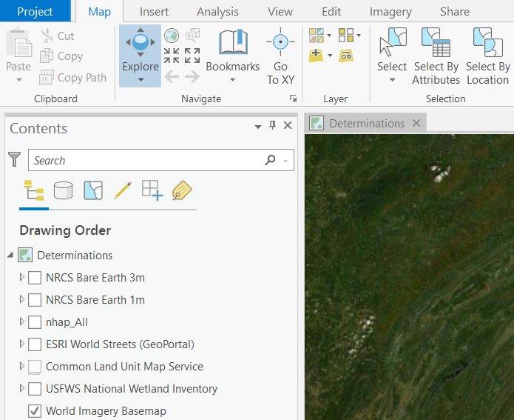The *Contents* pane updates contextually based on what type of content you are working with in ArcGIS Pro, however it most frequently contains the list of layers and tables in a map, or the list of page elements in a layout. If the *Contents* pane is closed while you are actively working in a map or a layout, it can be restored by clicking the *View* tab on the *Ribbon* and then clicking *Contents*.

When working in a map, the list of its layers and visibility status is available in the *Contents* pane along with options to view the layers by drawing order, selectable layers, editable layers, snapping properties, or labeling status. In GNT Pro, most of the operational layers generated by the tool are created with specific names that should not be changed to preserve automation.

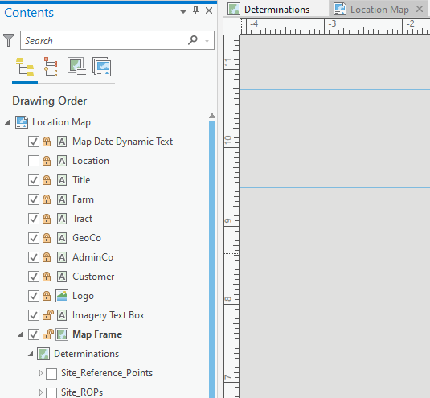

When working in a layout, the *Contents pane* contains a list of all elements on the layout page, as well as the associated map’s contents in a group. Layout elements can be locked in the *Contents* pane so that they cannot be changed. The elements in the *Contents* of the provided layouts have specific names that should not be changed to preserve automation.

## Map Tab

Most of the work in the tool involving navigating the map frame or adding data takes place on the *Map* tab of the *Ribbon*.

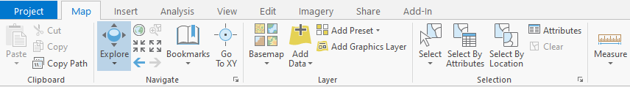

Commonly used ArcGIS Pro tools on the *Map* tab are:

* ***Explore*** – Used to navigate the map (pan/zoom) and to identify features. A variety of additional zooming options are available to the right of the *Explore* tool.
* ***Basemap*** – Select from a set of nationally available basemaps. Note: You may prefer to use local imagery or image services instead of basemaps for some projects.
* ***Add Data*** – Used to open a browser to find geodata files on your system, select them, and add them to the *Map*, where they will then appear in the *Contents* pane.
* ***Select*** – Used to select features in the *Map*.
* ***Attributes*** – Used to open the *Attributes* pane. Also available on the *Edit* tab.
* ***Clear*** – Used to clear the currently selected features.
* ***Measure*** – Opens an interactive measuring widget for temporary, on-the-fly measurements.

## View Tab

The *View* tab has buttons that will open various other windows in ArcGIS Pro and is useful for finding or re-opening panes that you’ve closed either accidentally or on purpose.

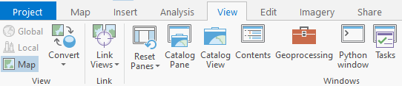

Commonly used tools on the *View* tab are:

* ***Catalog Pane*** – Used to open the *Catalog* pane.
* ***Contents*** – Used to open the *Contents* pane.
* ***Geoprocessing*** – Used to open the *Geoprocessing* pane. As tools are run in the *GNT* toolbox they will open within the *Geoprocessing* pane.

## Edit Tab

The *Edit* tab has buttons that will be used during the editing steps of the GNT workflow.

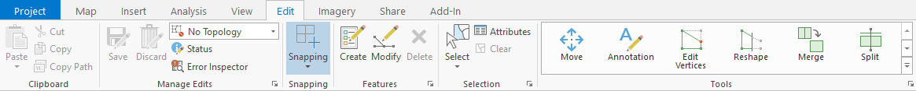

Commonly used tools on the *Edit* tab are:

* ***Save [Edits]*** – Used to Save edits. This save icon is denoted by the pencil in front of it.
* ***Discard*** – Used to Discard Edits without saving them. This icon has the same editing pencil in front of it as the *Save* icon on the *Edit* tab.
* ***Attributes*** – Used to open the Attributes window to update attribute values of selected features.

## Project Tab

The *Project* tab has buttons for saving projects, setting *Options*, managing Portals, and exiting ArcGIS Pro.

## Quick Access Toolbar

The *Quick Access Toolbar* is a customizable toolbar that appears above the *Project* tab in the top-left corner of ArcGIS Pro. Tools on it are accessible, regardless of your current tab.

This is a screenshot of the ArcGIS Pro Quick Access Toolbar, that shows additional tools that have been added to it to customize its appearance.

Some suggested tools to add to the *Quick Access Toolbar* are:

* ***Explore***
* ***Previous Extent***
* ***Next Extent***
* ***Add Data***
* ***Select (Features)***
* ***Clear (Selected Features)***
* ***Zoom to Selected Features***

Instructions for customizing the *Quick Access Toolbar* are available [here](https://pro.arcgis.com/en/pro-app/latest/get-started/quick-access-toolbar.htm) (external link to the ArcGIS Pro Online Help page).

## Layout

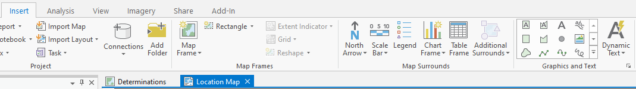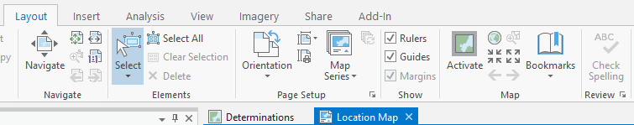A *Layout* in ArcGIS Pro is a page view used to arrange and apply settings to map products elements prior to map production. Due to the context-driven menus in ArcGIS Pro, when a *Layout* is active in the view, the *Ribbon* changes to display different tabs and tools and the *Contents* pane changes to show *Layout Elements* in addition to the *Map Frame’s* layers. The *Map* tab is replaced by the *Layout* tab, and the *Insert* tab is updated to show several tools for commonly used map making *Elements*. An *Element* is any object created on the *Layout* page, such as a *Map Frame*, *Legend*, *North Arrow*, *Scale Bar*, or *Text Box*.

Commonly used tools on the *Layout* menu include:

* ***Select*** – Use to select *Elements* on the page. Once selected, an *Element’s* properties can be viewed and adjusted (note: element must be unlocked in Layout Contents pane to change it).
* ***Navigate*** – Use to zoom in or out or pan around the *Layout* page, not the map within the page, if present.
* 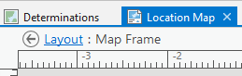A screenshot of the Activate button fro ArcGIS Pro.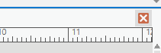***Activate*** – This function is found in the *Map* section of the *Layout* tab. It is used to activate the selected *Map Frame* on the *Layout* page which changes the *Layout* tab back to the *Map* tab and allows you to use *Map* functions like ***Explore*** while viewing the *Layout* page. This is used to adjust the extent and scale within the *Map Frame* interactively while the *Layout* page is visible. *Activation* of a *Map Frame* must be closed to change back to the *Layout* tab and tools and work with *Layout Elements* again. This can be done by clicking the red “x” at the top-right of the ruler bars while a *Map Frame* is activated, or by clicking the *Back* button or *Layout* link at the top left of the *Layout View*.

The *Contents* pane for a *Layout* displays the *Layout’s* *Elements*, as well as the *Map Frame* and its layers. In addition, the items listed on the *Contents* pane of a *Layout* can be locked or unlocked. Locked *Elements* cannot be renamed, resized, or repositioned. Unlocked *Elements* can be renamed, resized, and repositioned. You can right-click a selected *Element* on the *Layout* page, or right-click the *Element’s* name in the *Contents* pane and choose *Properties* to view the *Element Pane* for the selected item and adjust its properties. Below is an example *Layout*.

Note: The *Map Frame* and *Legend* *Elements* in the *Contents* pane expand and behave like a group layer.

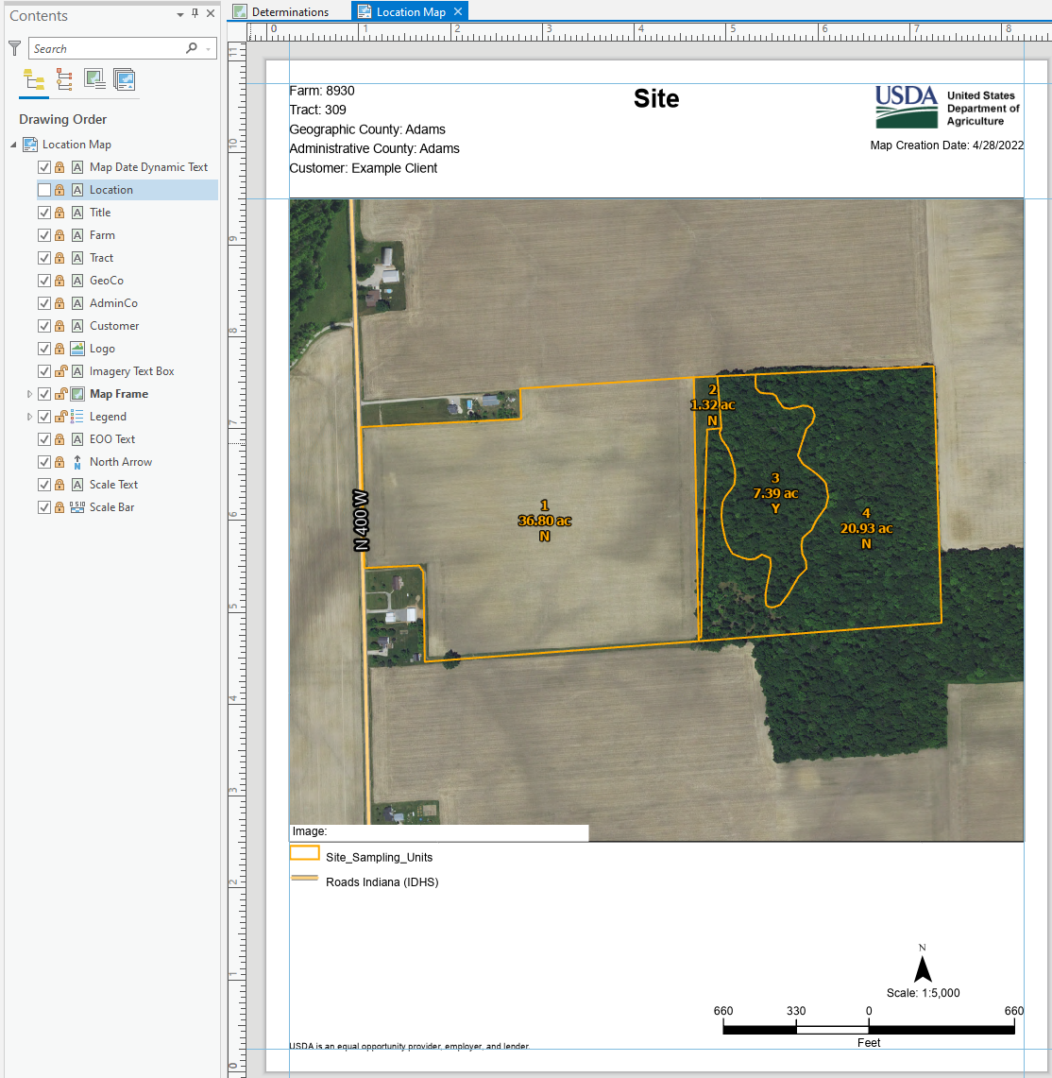

**Legend**

**Map Frame**

**CONTENTS**

**LAYOUT VIEW**

## Running a Toolbox Tool

This section describes how to run a tool in a toolbox within ArcGIS Pro. The individual tools in GNT may contain required parameters users must complete, optional parameters for users to complete, and auto filled or pre-filled parameters that users should not change.

### Opening a Tool

To open a tool from a toolbox –

* Open the *Catalog Pane* (from the *View* tab of the *Ribbon*)
* Make sure the contents of the *Project* are displayed in the *Catalog Pane* by clicking *Project* at the top of the window.
* Expand *Toolboxes*.
* Expand the *GNT* toolbox.
* Double-click the desired tool.
* The tool will open in the *Geoprocessing* pane or window. The *Geoprocessing* pane or window may be floating, docked, or hidden. Adjust the geoprocessing window to view and enter the required parameters and run the tool.

### Completing Tool Parameters

GNT tools could have required parameters, optional parameters, or auto-filled parameters. All required parameters must be filled out before a tool can be run. Specific methods for populating the parameters are covered in more detail in their respective lessons. The following general tips are provided when filling out tool parameters:

* Required parameters will usually have a red asterisk in front of them if they are not yet completed. They must be filled out before a tool can be run.
* Optional parameters will usually be labeled as (Optional) or won’t have a red asterisk in front of them.
* Parameters might have a picklist. Click the dropdown arrows to review and select choices.
* If a parameter instructs you to select a layer from the provided dropdown, then do so. Do not try to add a layer from the file system using the browse folder when *from dropdown* is present unless specifically directed to do so by this user guide or the help tip for that parameter.
* Sometimes Optional parameters might be available when you expand the carat/arrow at the heading of a group of parameters. Tool lessons will call this out where applicable.
* Anything marked (Auto-populated) or (Do not change) should not be altered manually be users.
* When parameters are populated, ***wait for the blue progress bar at the top of the geoprocessing window to finish cycling before updating the next parameter or running the tool***.
* Some parameter selections may hide or show new parameter options.
* Review all parameters before clicking *Run* in any tool.
* If a parameter has a red “x” or yellow triangle, hover over the icon for a descriptive message.

### Running a Tool

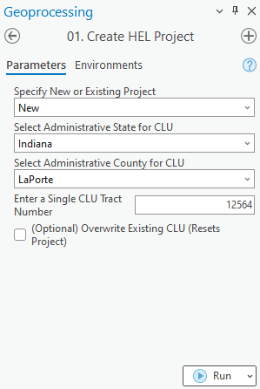After completing entries for tool parameters, click the *Run* button at the bottom of the form for the tool.

While the tool is running, a status message will appear at the bottom of the *Geoprocessing* tool window. The progress bar will cycle while the tool runs. The red-square button acts as a stop or cancel function and will end the operation of the tool. The *View Details* text is a link to open another window that will show more detailed status messages of the tool as it runs.

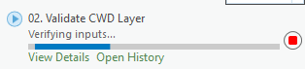

A screenshot of the status message that appears at the bottom of the Geoprocessing window when a tool completes successfully with no warnings or errors.When a tool is finished running, it will show a status color and a message. Green indicates the tool ran successfully with no errors or warnings. Yellow indicates the tool ran but had warnings that you may want to review. Red indicates the tool failed. When a tool fails, read the error messages and review the tool instructions. This may help you to re-run the tool successfully.

### Reviewing Tool Error Messages

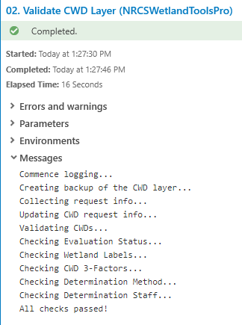After running a tool, you can click the *View Details* link in the status message at the bottom of the tool window for more information. This is useful if there are warnings (yellow status message) or errors (red status message).

After clicking *View Details*, another window will open that contains sections for *Errors and warnings*, *Parameters*, *Environments*, and *Messages*. By default, *Parameters* will be expanded and displayed, but you can collapse that section and expand the *Messages* section for useful tips or hints. For example, a tool may have a red error message that a required parameter is incorrect, or input data is missing. You should go back and complete any instructions provided in the *Messages* before rerunning a tool or continuing the determination workflow.

# Appendix B – Basic Editing in ArcGIS Pro

This appendix provides basic details for how to edit in ArcGIS Pro. It is not comprehensive and if you need further assistance, you should request it from your State Tool Administrator and/or State GIS Specialist, as well as request options for possible ArcGIS Pro training courses from ESRI.

## Edit Tab

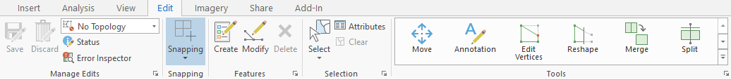Most functions and tools needed for editing will be found on the *Edit* tab of the ArcGIS Pro *Ribbon* when a map view is active. The buttons on the *Edit* tab will often be used to open additional panes with more tools and functions used for the actual edits. The *Edit* tab also has a *Tool Gallery* area (right-side of the below screenshot) that you can customize to show your favorite tools.

## Select Features

A screenshot of the select features tool in ArcGIS Pro.Many editing tools in ArcGIS Pro involve the step of selecting features. Often a select tool will be included directly in a given tool’s pane, if necessary. Otherwise, the standard select features tool from the *Edit* tab or *Map* tab can suffice.

## Start/Stop/Save/Discard Edits

ArcGIS Pro does not use *Start Editing* or *Stop Editing* functions by default to open and close an edit session. However, ArcGIS Pro does include options to enable such settings. If your state has directed you to implement these optional settings in your projects, use them as directed. They will not interfere with the normal GNT workflow other than to start or stop editing. If these optional settings are not enabled, then any editable layer can be edited in a project at any time.

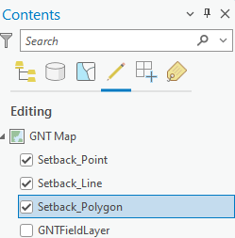For normal ArcGIS Pro use, editing is possible on any editable layer in a map. You can control whether a layer is editable by clicking the *List By Editing* button at the top of the *Contents* pane for an active map. The checked layers will be editable. By default, GNT sets the editable status as active for its operational or business layers when they are loaded. It is not recommended to disable the editable status of any of the business layers for GNT, and instead to manage your edits by turning off the selectable or visible status of any given layer when it is not the focus of current edits.

If any layer has status problems regarding its ability to be edited, a warning or error icon will be displayed to the right of the layer in this list. The icon can be clicked or hovered for more details.

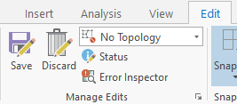ArcGIS pro does include a *Save [Edits]* button on the ribbon of the *Edit* tab. It is the icon of the save diskette with a pencil over it. This icon is labeled *Save*, but this should not be confused with saving the project. To clarify this difference, this user guide and its lessons refer to this button as *Save [Edits]*.

The *Discard* button is next to the *Save [Edits]* button and can be used to discard all currently pending edits and return your edited data to the state it was in prior to beginning edits or the state it was in the last time you used *Save [Edits]*. This is an undo for all pending edits.

## Undo/Redo

A screenshot of the Quick Access Toolbar in ArcGIS Pro with the undo and redo buttons highlighted to illustrate where those functions are found.ArcGIS Pro has *Undo* and *Redo* buttons on the *Quick Access Toolbar*. These can be used to undo or redo recent edits, until you click the *Save [Edits]* or *Discard* button. Once edits are saved or lost, the only way to correction previous edits is to perform new edits.

# Appendix C – Working with Annotation

ArcGIS Pro can create annotation layers from existing labels. Annotation layers are useful for allowing a user to edit all aspects of a label to override the automated labeling engine placement. In GNT Pro, creating an annotation layer from existing labels may be useful for any of the operational layers created by the tool to improve map product clarity.

Note: When using annotation layers, they will need to be manually enabled as visible prior to exporting a map.

Warning: An annotation layer should only be created when final map making is taking place. Scenarios which may lead to further edits or starting over with an operational layer may result in loss of links between the operational layer and the created annotation layer. In that scenario, a new annotation layer will need to be created.

To create an annotation layer:

* 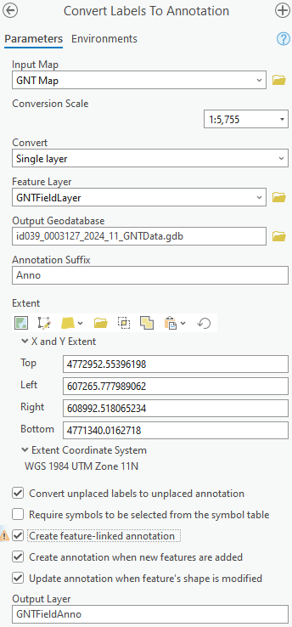Pan and zoom to the desired scope for your labels in the map. The current scale will drive the size of the labels in the annotation layer.
* Right-click the layer in the *Contents* pane for which you want to create annotation.  
  Hint: The layer must have labels visible already.  
    
  Click ***Convert Labels***, and then click ***Convert Labels to Annotation***. The *Convert Labels To Annotation* pane opens. Complete the following entries:
  + The input map should be *GNT Map*.
  + A conversion scale has been set automatically. You can adjust it, but this could change the size of the labels in unexpected ways.
  + Convert a *Single layer*.
  + The layer that was right-clicked should appear automatically in *Feature Layer*.
  + Click the folder and navigate to your project folder to select the local GNTData Geodatabase (ending in .gdb).
  + Check on *Convert unplaced labels…*
  + Check on *Create feature-linked anno…, and update anno…*
  + Rename the output layer as desired, but include “Anno” at the end of the name.
* 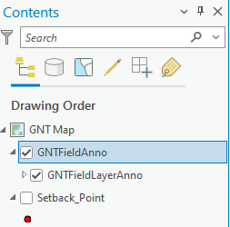Click ***Run***. An annotation layer will be created and added to the *Contents* pane for the map. The automatic labeling on the input layer will be deactivated. You may need to make the newly added annotation layer visible in the *Contents* pane, if not already visible. As a group layer, make sure to expand it and that both the group and its contained annotation layer are set to visible.  
  Note: The layer listed within the group can also be expanded to control specific label classes if the source layer had multiple label classes.

If label density is high, some labels may have been generated in the annotation layer but are not placed on the map. These are called “Unplaced” labels. To show unplaced labels:

* Expand the annotation group layer heading, right-click the annotation layer name within the annotation group, and then click ***Attribute Table***.
* 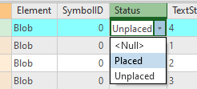In the attribute table, find the *Status* column and look for any *Unplaced* labels. Click the box where it says *Unplaced* and change it to *Placed*. Press enter on the keyboard after changing the selection. This is an edit, so to save it you need to click the *Edit* tab in ArcGIS Pro and then click *Save [Edits]*. The label should now appear on the map.
* Close the attribute table after placing any unplaced labels.

To move an annotation label without showing a leader line:

* Click the *Clear* tool to clear selected features, if any.
* 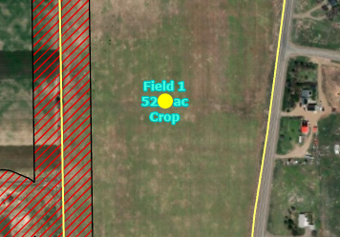Click the *Edit* tab on the ArcGIS Pro *Ribbon* and then click *Modify*. In the *Modify Features* pane, under the *Alignment* section, click *Move*.
* Use the *Select one or more features* tool in the *Move* pane to select an annotation label to move. Once selected, click the *Move* tool.
* Drag and drop the selected annotation feature to move it. *Save [Edits]* after moving a label.

To move an annotation label and show a leader line:

* Click the *Clear* tool to clear selected features, if any.
* 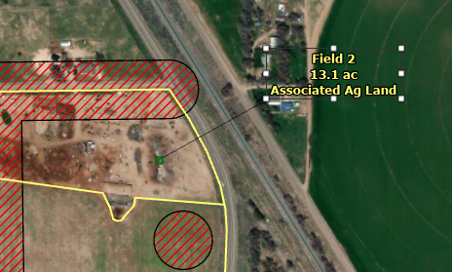Click the *Edit* tab on the ArcGIS Pro *Ribbon* and then click *Modify*. In the *Modify Features* pane, under the *Alignment* section, click *Annotation*.
* Use the *Change the selection* tool in the Annotationpane to select an annotation label to move. Once selected, click the *Annotation* tool.
* Drag and drop the selected annotation feature to move it. A leader line will appear if the label style initially included leader lines (if not, right-click the label and click *Add Leader*).
* You can also select the anchor point for the annotation leader that appears and drag and drop it to move it.
* *Save [Edits]* after moving a label or its leader line anchor point.

To change symbology for an annotation layer, it is usually best to do it via the *Labeling* appearance properties on the source layer BEFORE converting the labels to an annotation layer. If you need to adjust afterwards:

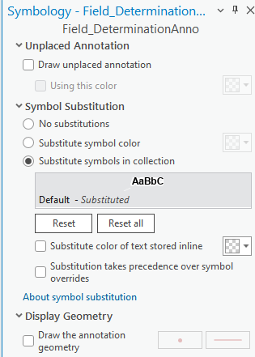

* Click the annotation layer in the *Contents* pane, click the *Appearance* or *Annotation Layer* tab that gets added to the *Ribbon*, and then click the *Symbology* button.
* In the *Symbology* pane under the *Symbol Substitution* section, select the *Substitute symbols in collection* option. Then double-click the symbol box beneath that option to open the symbol editor.
* Click the *Properties* tab and edit the symbol and its callout leader as desired in the subsequent panes and then click *Apply*.
* When finished, changes will be applied to all labels in the annotation layer.

# Appendix D – Recovering the Installed Layout

The default *Layout* deployed with GNT Pro can be reset at any time, if needed.

Warning: This will potentially undo any state customizations and should only be done if the original layout was lost or the user explicitly wants to start over on layout customization.

* Open the *Catalog* pane and expand the *Layouts* section.
* Select, right-click, and delete the existing default *Layout* (*GNT Layout*), if necessary.

Warning: Do not delete the *GNT Map* object from the *Maps* section of the *Catalog* pane.

* Click the *Insert* tab on the ArcGIS Pro *Ribbon* and then click *Import Layout*. Then at the bottom of the window that appears, click *Import Layout File…*
* Navigate to ***<install folder>\Map_Layouts***. Select the *GNT Layout* file present in that folder and then click ***OK***.
* The *GNT Layout* will be added to the *Layouts* section in the *Catalog* pane. Also, an additional *GNT Map* will be added to the *Maps* section of the *Catalog Pane*, named *GNT Map1*.
* In the *Maps* section of the *Catalog Pane*, select *GNT Map1*, right-click it, and delete it. You will receive a confirmation prompt to confirm deleting the extra map. Click ***Yes***.
* The new *GNT Layout* will have opened in the central viewing area of ArcGIS Pro when it was imported. You now need to associate the existing *GNT Map* with the new *GNT Layout*.
  + With the *GNT Layout* open and active in ArcGIS Pro, go to its *Contents* pane (the list of elements in the layout).
  + In the *Contents* pane, right-click ***Map Frame*** and then click ***Properties***.
  + In the *Format Map Frame* pane that opens, click the dropdown under *Map Frame*, and select *GNT Map*.
* Close the *Format Map Frame* pane.
* Save the project (***Project à Save***) when finished.

# Appendix E – Troubleshooting

To begin troubleshooting, always refer to the specific tool instruction in the User Guide or the tips in this section. After exhausting troubleshooting items listed below, contact your State Tool Administrator for direct assistance. If errors persist, the State Tool Administrator will submit a ticket in Gitub, as described in the *Issue Reporting* section, below.

## Common Tool Errors (red status)

The errors in this section appear when a tool has an error message (results status is red). The following are common things to verify before requesting assistance or reporting a problem.

* **Tool parameters were not correctly populated –** Review the entered parameters and the documentation in the Lessons and User Guide to assist you in correctly completing the parameters. Also verify that the requested layer or data in any given parameter is correct. After correcting parameter entries try to rerun the tool.
* **Incorrect Portal Connection** – Review the active portal in the *Portal Status* area at the top-right corner of ArcGIS Pro. Confirm the correct portal is selected. If necessary, switch the active portal to the appropriate portal and run the tool again. As a reminder, the following tools require the following portals:
  + Production:
    - *Create GNT Project (A.01.)* – GeoPortal
* **Cannot perform create feature or modify feature edits due to an error showing table not found with a long unique ID string in the error message –** Discard edits (if necessary). Expand the *F. Utilities* toolset. Run the *Attribute Rules – Repair* tool. After the tool runs, close the *Determinations* map. Save the APRX. Go to the Catalog pane. Expand the *Maps* section. Double-click the *Determinations* map to re-open it. Try editing again.

## Troubleshooting Edit Locks

When attempting to make edit corrections to existing layers after some tools, the layers can sometimes become locked by ArcGIS Pro. To work around this, perform the following actions to break the lock.

* Option 1 – Close and re-open the *GNT Map*:
  + 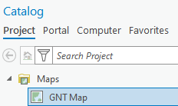In the ArcGIS Pro central viewing area, find the *GNT Map* tab and close it.
  + Open the *Catalog Pane* and then expand the *Maps* section.
  + Double-click the *GNT Map* item in the *Catalog Pane* to re-open it.
  + Attempt edits again. If layers are still locked, proceed to Option 2, below.
* Option 2: Remove the locked layer and then Undo the remove –
  + 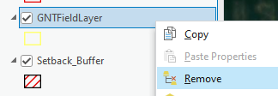Right-click the layer that is locked for editing and click ***Remove*** from the pop-up menu.
  + 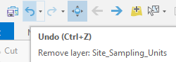At the top-left of the ArcGIS Pro window, click ***Undo***. The layer will be restored to the map.  
    Hint: If Undo is greyed out, click the *GNT Map* tab name in the view area.
  + Repeat this for any layers affected by editing locks.
  + Attempt edits again. If layers are still locked, proceed to Option 3, below.
* Option 3: Close and re-open the project –
  + Save the project (click ***Project à Save***).
  + Close the project (click ***Project à Exit***).
  + Go to the project folder and double-click the project name to re-open it.
* Option 4: Restart the project.
  + Close the project
  + Delete the project folder
  + Open the state template and start again

## Issue Reporting

Review existing issues and report new issues on GitHub at:

<https://github.com/USDA-NRCS/GNT-Pro/issues>

Note: You will need to create a GitHub account to report issues. Review open issues to see if the error or problem was already reported by a different user. Update or add further information to existing issues or re-open closed issues, if needed.

When you report or create a new issue, please provide a description, screenshots, and/or logs (if relevant). Please include your USDA e-mail address in either your issue description or your GitHub profile so that developers can contact you.

Sometimes developers can resolve an issue that your report without directly contacting you. If an issue can be resolved without further contact, comments may be added directly to the issue posts on GitHub and you can always check there for the latest changes. If you have disabled e-mail notifications for issue updates on GitHub, you may not see any communication that an issue was acknowledged or resolved and directly reviewing your issues may be the only way that you see that it is being reviewed or has been addressed.

Note: Not all resolved issues will be immediately deployed in the current release and an aggregation of fixes may be gathered before a new release is issued.

1. Special templates created by NRCS State Offices, if any, are intended for internal users as they typically contain data dependencies on internal USDA resources. TSPs would need to use the default template within the GNT folder or their own custom template subsequently created from the default template (see instructions later in this guide).